Attorney Wellness During the Pandemic
Brain Health + Mental Strength = Resilience
Debra Austin, J.D., Ph.D., Professor of the Practice, University of Denver Sturm College of Law
Lawyer Well-being Newsletter at www.debraaustin.com

Brain Health
Strengthen the Hippocampus: Exercise
- Enhances blood and oxygen flow
- Improves blood flow deeper into body tissues
- Increases blood volume in Hippocampus which maintains its health and function
- Enhances distribution of food and elimination of waste. The Brain Requires: 25% of calories consumed; 20% of oxygen breathed; & 25% of body’s total blood flow
- Increases & balances neurotransmitters
- Dopamine (motivation, pleasure, meaning);
- Serotonin (mood, anxiety, sleep);
- Norepinephrine (mood, arousal, attention, perception, motivation)
- Stimulates production of Brain Derived Neurotropic Factor (BDNF)
- Protein that helps create new neurons, protect existing neurons, & encourage synapses formation
- BDNF production enhanced by Exercise, Calorie Reduction, Intellectual Stimulation, Curcumin (active ingredient in spice Turmeric), and Omega-3 Fat DHA
Exercise & Resilience
- Exercise can make it easier to cope with stressful experiences. Researchers called over 2,000 participants, ages 33 to 84, every night for eight days. On days when participants were active, stressful work and personal events were less taxing.
- Busy lawyers should not miss workouts. Research requiring active adults to reduce their physical activity resulted in impaired mental well-being. Participants experiencing forced periods of inactivity reported increased fatigue, anxiety, hostility, and depression, as well as a decline in life satisfaction.
Exercise & Brain Volume
- A new study adds to that data by demonstrating that active older adults have bigger brains than inactive folks. Exercise is associated with larger brain volume in the elderly, which helps to explain how it defends against cognitive decline. Researchers divided 1,557 multi-ethnic participants, with an average age of 75, into three groups. They collected information on leisure time physical activity and conducted MRI scans on the participants. When they compared the brain volume of the most active third to that of the least active third of participants, they found that the active group had larger brains, and that was equivalent to a reduction in between 3 and 4 years of aging. Activities reported by the participants included walking, gardening, swimming, and dancing.

Exercise & Cognitive Capacity
- A 2011 meta-analysis of 1,603 articles on the relationship between cognition and exercise found that exercise can prevent cognitive decline and heal cognitive impairment. Exercisers had larger hippocampus volumes (the structure where memories are processed and stored) and greater synaptic connections (the links between brain cells that are vital for thinking and memory).

Enhance Memory: Sleep
- 90 Minutes to 2 Hours to first REM Stage. During REM
  - Hippocampus & Amygdala very active
  - Communication between neurons at rate equal to or higher than when awake
  - Memory consolidation genes activated, which helps formation of new neural connections
- Sleep Research
  - Subjects awakened during REM lost ability to learn new information
  - Loss of 1 night of sleep = 30% cognitive decline
  - Loss of 2 nights of sleep = 60% cognitive decline
  - Less than 6 hours of sleep for 5 nights in a row = 60% cognitive decline
- Sleep Deprivation
  - Diminishes attention, working memory, executive function, quantitative skills, logical reasoning ability, mood, and fine & gross motor control
  - Accelerates Aging Process
  - Impairs ability to use fuel/food creating risk of diabetes and obesity
  - A study on the sleep quality and brain atrophy of 147 middle-aged adults found that poor sleep quality was correlated with reduced brain volume. The study did not reveal whether poor sleep quality was a cause or a consequence of reduced brain volume. Difficulties falling asleep or staying asleep have been linked to cognitive decline and an increased risk of Alzheimer’s disease. The areas of the brain that shrank are responsible for reasoning, planning, and language processing (frontal); hearing and memory (temporal); and movement, taste, and touch (parietal). These areas of the thinking brain process information and conduct higher-order reasoning.
- Naps Improve Cognition
  - 26-minute nap improved NASA pilot performance by 34%
  - 45-minute nap improved cognition for at least 6 hours

Improve Cognitive Function: Diet
- Aging results in inflammation and deterioration of body functions, which contribute to frailty. Researchers found that consuming the MedDiet for a year reduced frailty and improved cognitive function in 323 elderly participants (age 65-79) from the UK, France, Netherlands, Italy and Poland. The beneficial outcomes were correlated with improving the diversity in the gut microbiome ecosystem of the participants. A high adherence to the MedDiet resulted in enhanced global cognitive ability; improved immune function, blood pressure, and arterial stiffness; and reduced bone loss in individuals with osteoporosis.
- The MedDiet includes lots of fruits, vegetables, nuts, beans, olive oil and fish; some eggs and dairy; and very little red meat, sugar and saturated fats. Some of the healthiest foods include broccoli, berries, almonds, walnuts, and salmon. A large variety of fruits and vegetables is recommended. The MedDiet can also reduce the risk of diabetes, heart disease, stroke, and some cancers. For the third year in a row, the MedDiet has been ranked first in the US News and World Report's "best diet" rankings.
- 160 sedentary adults over 55 & at risk for cognitive decline
  - Aerobic exercise improved cognition
  - A combination of aerobic exercise plus heart-healthy Dietary Approaches to Stop Hypertension (DASH) diet improved cognition even more
    - Vegetables, fruits, whole grains, fat-free or low-fat dairy products, fish, poultry, beans, nuts, and vegetable oils
    - Limit salt, sugar, and saturated fat

Protect Memory: Limit Alcohol Intake
- Law Students: 43% binge-drinking once & 22% binge-drinking at least twice in the past 2 weeks
- Lawyers: 23% of licensed, employed attorneys qualify as problem drinkers
- Alcohol
  - Decreases Glutamate
    - Impairs learning & memory
    - Prevents neurogenesis (birth of new brain cells) in hippocampus
    - Even in social drinkers at BAC .03%
  - Increases
    - GABA: Causes sedation
    - Dopamine: Inspires Repeat Behavior
    - Endorphins: Pleasure

Mental Strength
Mindfulness
- Being fully aware of something and paying attention to the moment, with acceptance and without judgment or resistance
- The Research: Mindfulness
  - Improves
    - Information processing
    - Decision-making
    - Concentration
    - Productivity
  - Increases thinking brain volume & improves connections between brain regions
  - Improves immune function
  - Promotes emotional intelligence
  - Decreases distraction
  - Reduces stress & anxiety
- Mindfulness Activities and Practices
  - Mindful Movement: yoga, tai chi & qigong
  - Three Questions Mindfulness Practice
    - When is the most important time? Now, because it is the only time which you have some control over.
    - Who is the most important person? The person you are interacting with.
    - What is the most important thing to do? Do your best to serve the person you are interacting with.
Meditation
- Meditation (Chade-Meng Tan)
  - Easy Way: Bring gentle and consistent attention to your breath for 2 minutes, and when your attention wanders, bring it back
  - Easier Way: Sit without an agenda for 2 minutes, shift from doing to being
- The Research: Meditation
  - Enhances productivity, learning, and health
  - Increases thinking brain volume
  - Improves attention, mood, and compassion
  - Strengthens immune system
  - Decreases stress-related cortisol
  - Improves disease/disorders: Cardiovascular, Asthma, Type II Diabetes, insomnia, anxiety
- Tips from Google’s Chade-Meng Tan
  - Like weight training, growth in meditation comes from resistance
  - When your mind wanders and you bring it back, your attention grows stronger
  - Lesson: there is no such thing as a bad meditation
- Doesn’t Require Large Time Commitment to be Beneficial
  - Students who practiced for 10 minutes per day for 2 weeks improved GRE scores (2013)
  - 15 minutes daily improved decision-making (2013)

Gratitude
- Gratitude Journal OR Gratitude Reflection
  - Things you are grateful for
  - Things you are proud of
  - People who have helped you
  - Notice Thin Slices of Joy: Blue Sky, First Sip of Coffee, Cute Animal Tweet Off
- The Research: Gratitude
  - Over 100 studies, people who practice gratitude
    - Have more positive emotions
    - Accomplish more personal goals
    - Sleep better & feel more alert, enthusiastic, and energetic
    - Have lower blood pressure, and live 7-9 years longer

Priming
- Prepare the brain with positive thoughts before demanding activity. Think of your best day, or a really good day, or something that makes you happy prior to undertaking something challenging. Research shows that in both business and academic settings, priming for positivity improves performance. Shawn Achor, The Happiness Advantage: The Seven Principles of Positive Psychology that Fuel Success and Performance at Work 46 (2010).

Yoga
- Increases GABA
  - Induces Calm & Improves Mood
  - Depression linked to low GABA
  - Highest GABA: Most Experienced & Most Frequent Practice

Tai Chi
- Tai Chi is a graceful low impact form of exercise that originated in China as a martial art. It is considered both meditation in motion and medication in motion. Research indicates Tai Chi can provide the following health benefits: better balance, improved flexibility, enhanced muscle strength, improved mood, and decreased stress, anxiety, and depression.
- Veterans with PTSD symptoms reported that Tai Chi improved their concentration and helped them manage intrusive thoughts. The participants wanted to continue their training and would recommend Tai Chi to a friend. Tai Chi improved insomnia, fatigue, and depression in breast cancer survivors. And in a small study, 6 healthy adults were given 12 weeks of Tai Chi training and scientists used magnetic resonance spectroscopy to measure biochemical markers of brain health. Researchers found increased N-acetylaspartate, an indicator of brain cell health, suggesting that Tai Chi may promote neuroplasticity, stimulate the birth of new brain cells, and/or protect brain cells against aging.

Nature Therapy
- Metadata research synthesizing 143 studies of over 290 million people reveals that exposure to greenspace lowers the stress hormone cortisol, heart rate, and blood pressure, as well as reduces the risk of type II diabetes, cardiovascular disease, and premature death. Participants lived in 20 countries, including the US, UK, Australia, France, Germany, Spain, and Japan where forest bathing is popular. Greenspace includes both undeveloped land with natural vegetation and urban parks.
- Forest bathing is a practice meant to reverse the effects of nature deficit disorder, for those of us who spend most of our time indoors. A slow and mindful walk through a forest, appreciating the experience with all your senses, can reduce stress, anxiety, and depression, while also improving sleep, the immune system, and cardiovascular health. The health benefits of the forest may come from the higher oxygen concentration and the presence of phytoncides, natural oils that defend plants from insects, bacteria, and fungi. Evergreens are the greatest generators of phytoncides.
- In an effort to determine an effective dose of nature therapy, researchers reviewed 155 studies and included 14 studies in their analysis. Participants were age 15 to 30 from Japan, the US, and Sweden, and time spent in natural settings was compared to time spent in urban settings. The research revealed that 10-30 minutes of sitting or walking in nature decreased cortisol, heart rate, blood pressure, and anxiety, while improving mood and boosting the rest-and-digest recovery system (parasympathetic nervous system activity).

Resources

Books on Exercise
- Spark (2008) by John J Ratey, MD
- Go Wild (2014) by John J Ratey, MD and Richard Manning
- The Joy of Movement (2019) by Kelly McGonigal, PhD

Books on Mindfulness & Meditation
- The Anxious Lawyer (2016) by Jeena Cho & Karen Gifford
- The Mindful Athlete (2016)by George Mumford
- Search Inside Yourself (2012) & Joy on Demand (2016) by Chade-Meng Tan

Books on Positive Psychology
- The Happiness Advantage (2010) and Before Happiness (2013) by Shawn Achor

Sign up for Debra’s Lawyer Well-being Newsletter, delivered to your email every Thursday, and appropriate for anyone interested in brain health and mental strength, at https://debraaustin.com/newsletter-2/.

Debra’s Articles available at https://debraaustin.com/research/.

Everybody talks about wanting to change things and help and fix, but ultimately all you can do is fix yourself. And that's a lot. Because if you can fix yourself, it has a ripple effect.
~ Rob Reiner

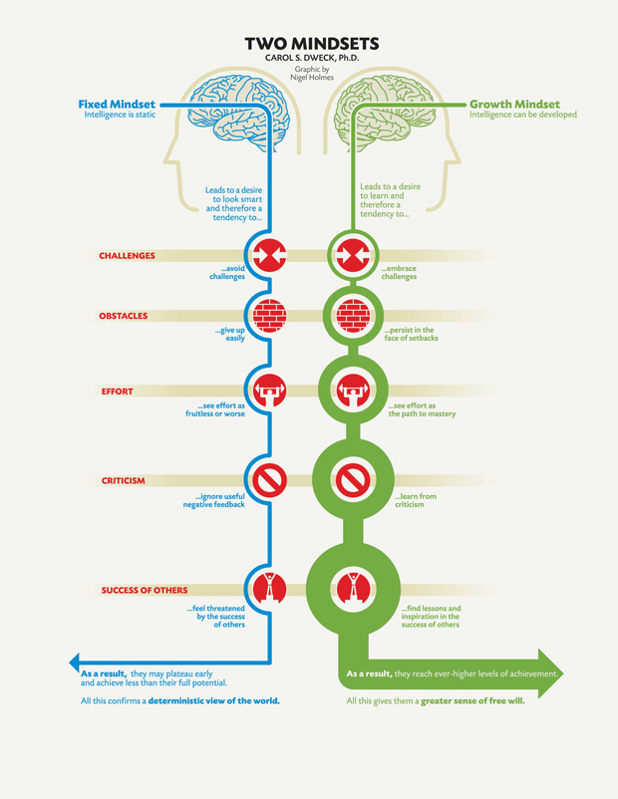
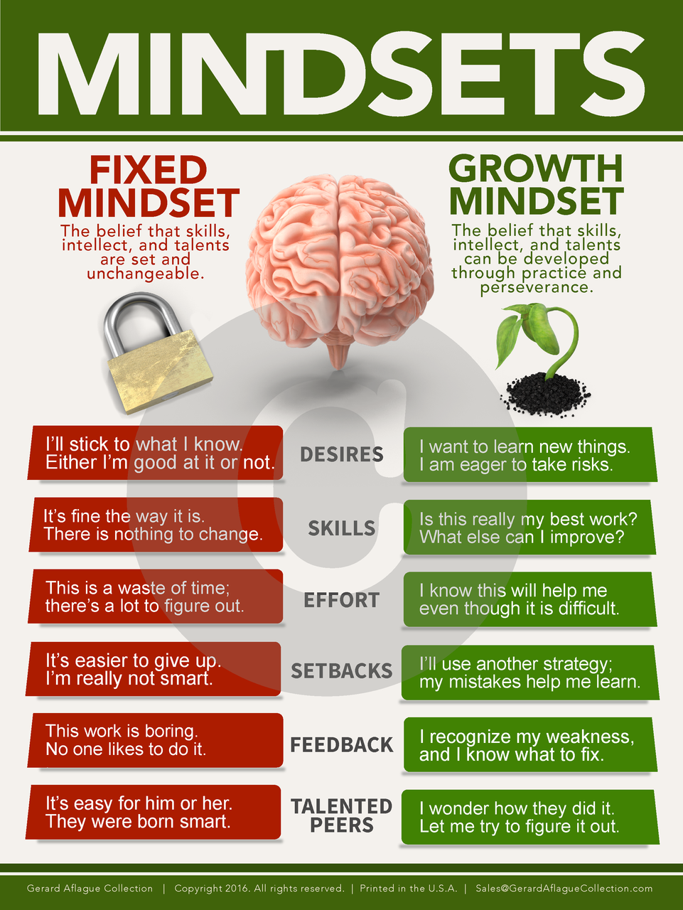
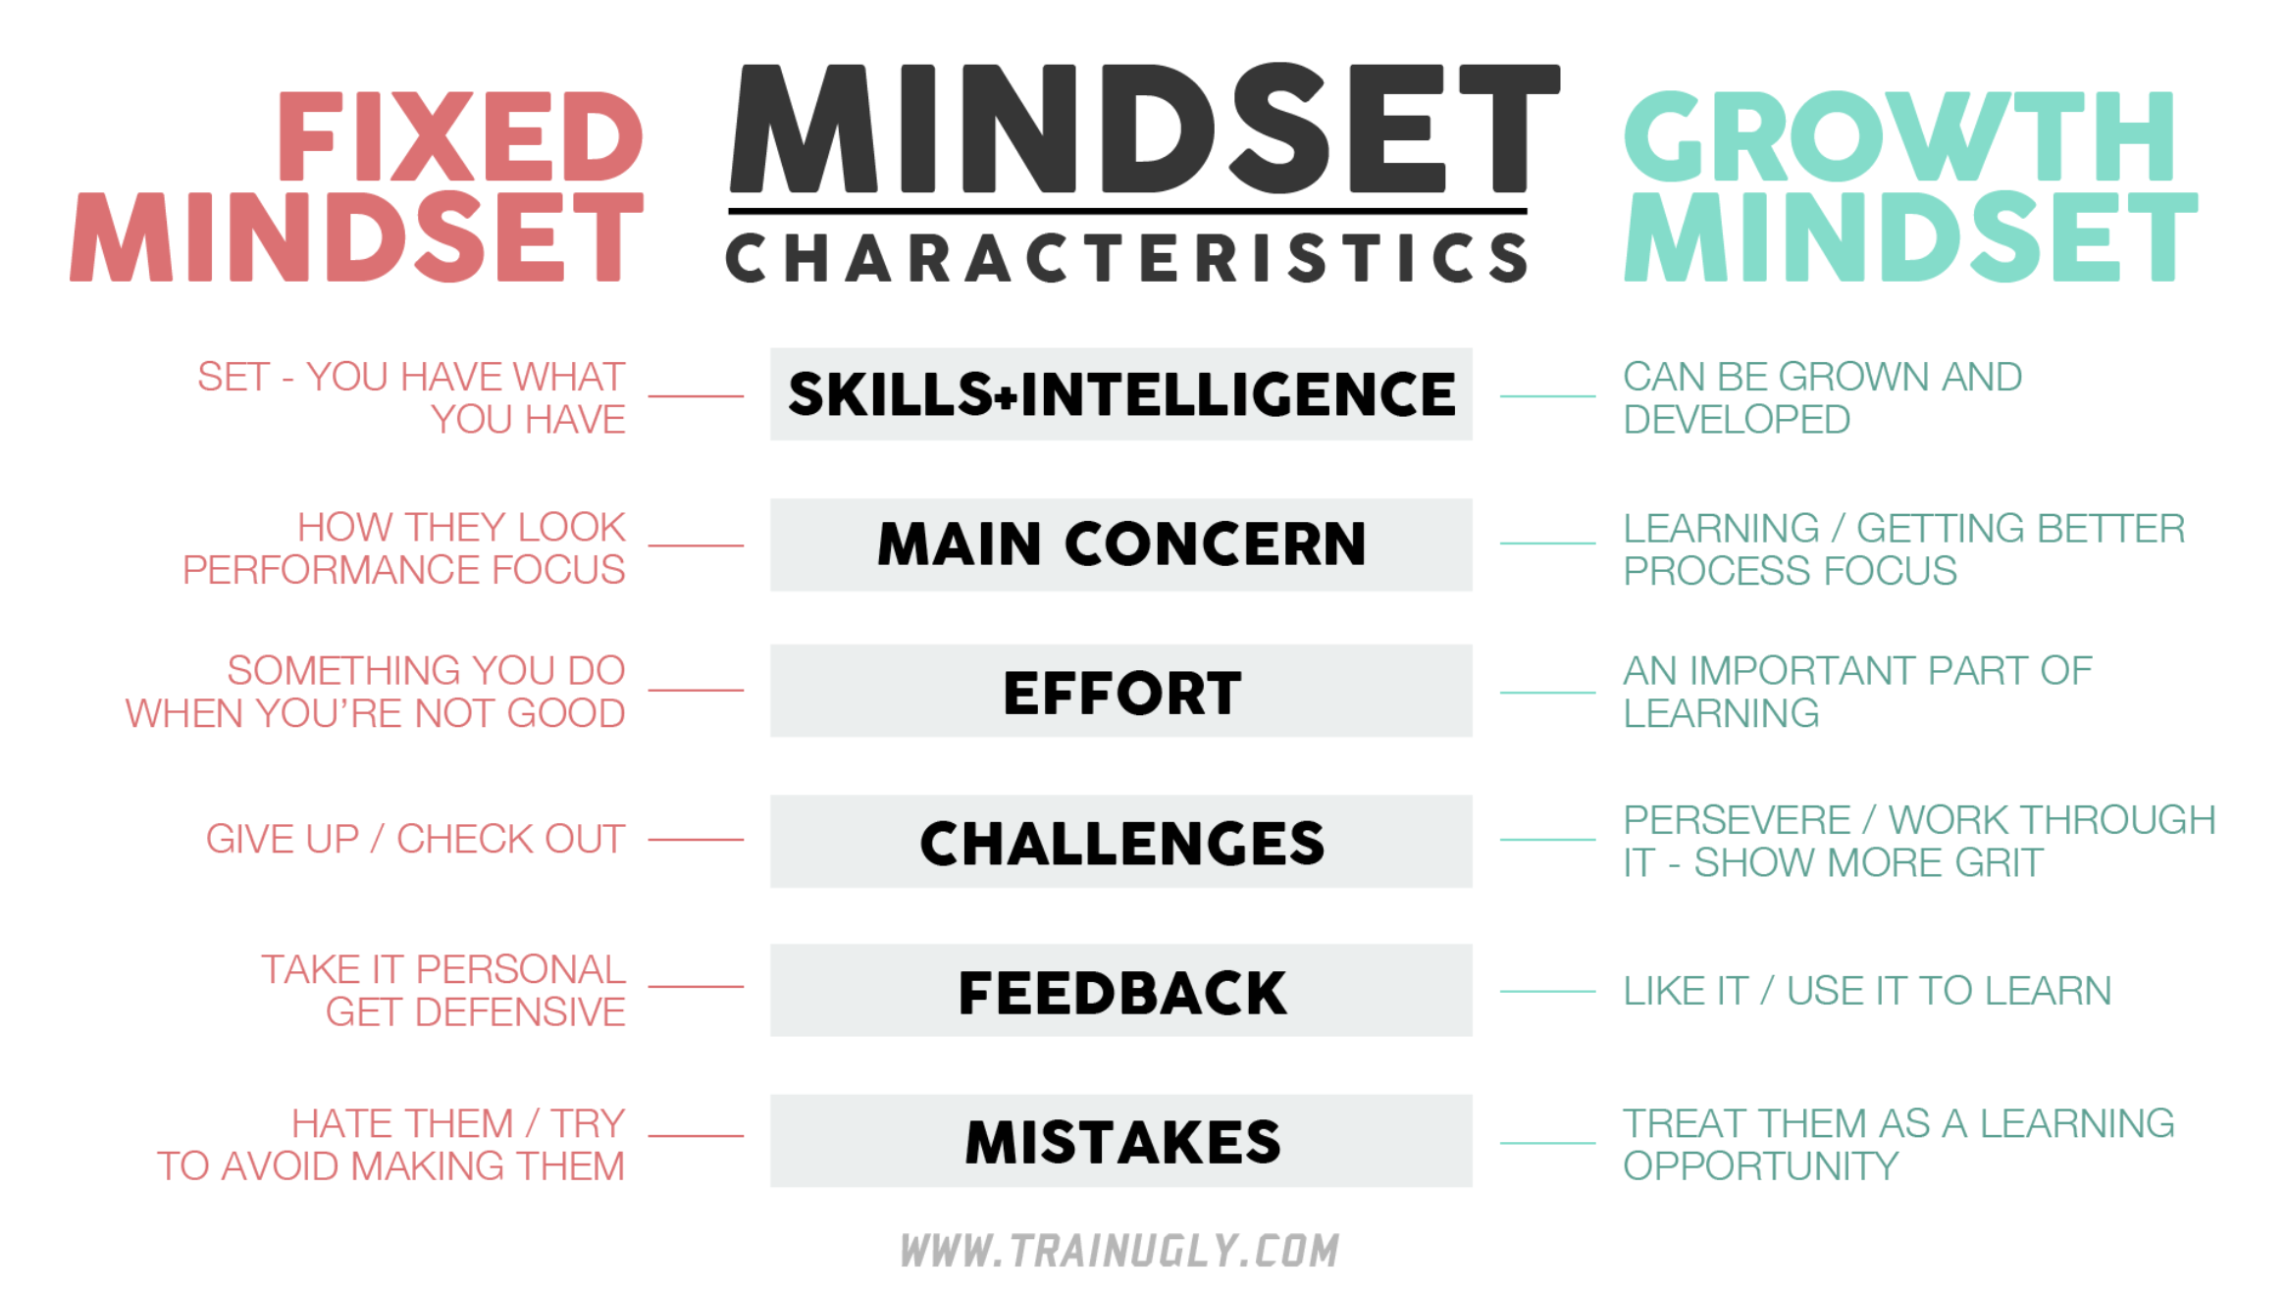

Growth Mindset Skills are Valued in Foundations for Practice Report
https://iaals.du.edu/publications/foundations-practice-whole-lawyer-and-character-quotient

- High Degree of Professionalism
- Strong Work Ethic
- Self-Awareness
- Enjoys Challenges
- Positive
- Gritty
- Resilient
- Resourceful
- Strategies for Learning from Feedback and Setbacks
- Manages Stress

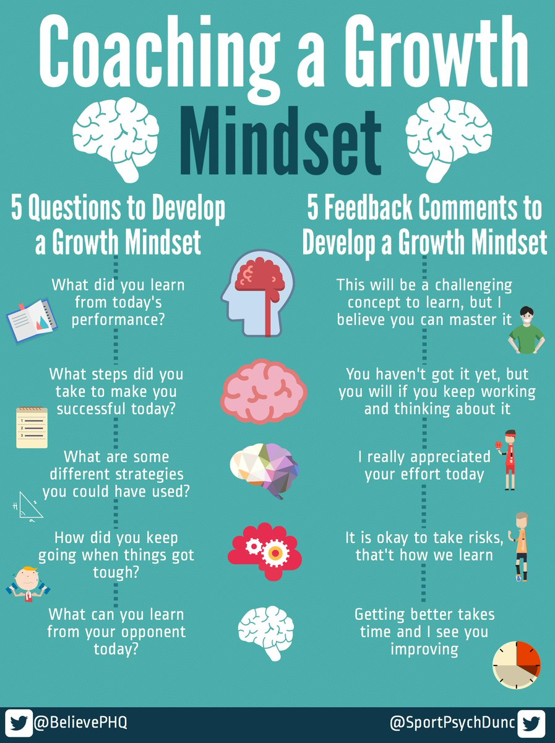
Dare to Lead by Brene Brown
Armored Leadership or Daring Leadership pages 74-75, 79-80
Perfectionism
Protecting our ego and fitting in is why we reach for armor in situations where we think being liked or respected is at risk because we may be wrong, or not have all of the answers, or might get in over our heads and not look smart enough. We also go on lockdown when our emotions may be perceived by others in a way that we can’t manage or control. If I’m honest about how I’m feeling, will I be misunderstood, judged, seen as weak? Will my vulnerability change the way you think of me or my ability? (74-75)
Leadership Armor: Driving Perfectionism and Fostering Fear of Failure
Perfection is not: (79)
- Perfectionism is not self-improvement. Perfectionism is, at its core, about trying to earn approval. Most perfectionists grew up being praised for achievement and performance (grades, manners, rule following, people pleasing, appearance, sports). Somewhere along the way, they adopted this dangerous and debilitating belief system: I am what I accomplish and how well I accomplish it. Please. Perform. Perfect. Prove. Healthy striving is self-focused: How can I improve? Perfectionism is other-focused: What will people think? Perfectionism is a hustle.
- Perfectionism is not the key to success. In fact, research shows that perfectionism hampers achievement. Perfectionism is correlated with depression, anxiety, addiction, and life paralysis, or missed opportunities. The fear of failing, making mistakes, not meeting people’s expectations, and being criticized keeps us outside the arena where healthy competition and striving unfolds.
Here’s how I (Brene Brown) define perfectionism: (80)
- Perfectionism is self-destructive simply because perfection doesn’t exist. It’s an unattainable goal. Perfectionism is more about perception than internal motivation, and there is no way to control perception, no matter how much time and energy we spend trying.
- Perfectionism is addictive, because when we invariably do experience shame, judgment, and blame, we often believe it’s because we weren’t perfect enough. Rather than questioning the faulty logic of perfectionism, we become even more entrenched in our quest to look and do everything just right.
Daring Leadership: Modeling and Encouraging Healthy Striving, Empathy, and Self-Compassion (80-81)
Conversations about perfectionism within trusting and brave teams can be healing and powerful. The goal is to get very clear about where, as a team, we’re the most likely to get swallowed by perfectionism, how it shows up, and how we distinguish perfectionism from healthy striving for excellence. Are there ways that we can check in with one another that work for everyone? Are there flags, warning signs, or indicator lights that we an all take responsibility for spotting? I’ve seen teams that are willing to have these conversations make profound changes, grow closer, increase their performance, and build trust in the process.

